Assignment 18.2

Below is the dataset which we will be using for this Assignment in all problems. It has been kept in local file system:-
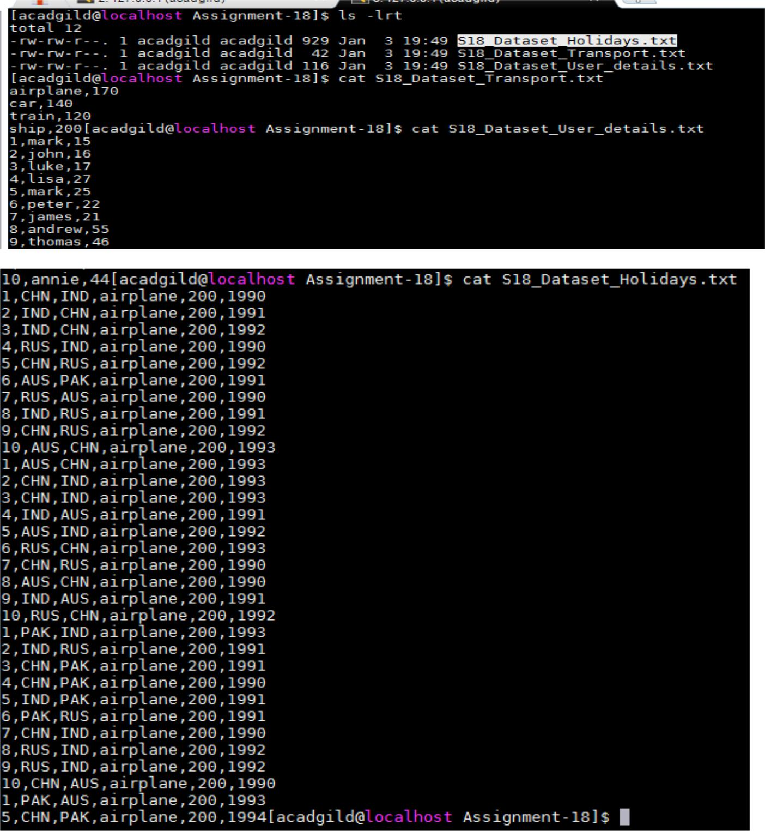
DataSet is uploaded in as follows:-

- val baseRDD1 = sc.textFile("/home/acadgild/Assignment-18/S18_Dataset_Holidays.txt")

- val baseRDD2 = sc.textFile("/home/acadgild/Assignment-18/S18_Dataset_Transport.txt")

- val baseRDD3 = sc.textFile("/home/acadgild/Assignment-18/S18_Dataset_User_details.txt")

- import org.apache.spark.storage.StorageLevel

- baseRDD1.persist(StorageLevel.MEMORY_ONLY)

- baseRDD2.persist(StorageLevel.MEMORY_ONLY)

- baseRDD3.persist(StorageLevel.MEMORY_ONLY)
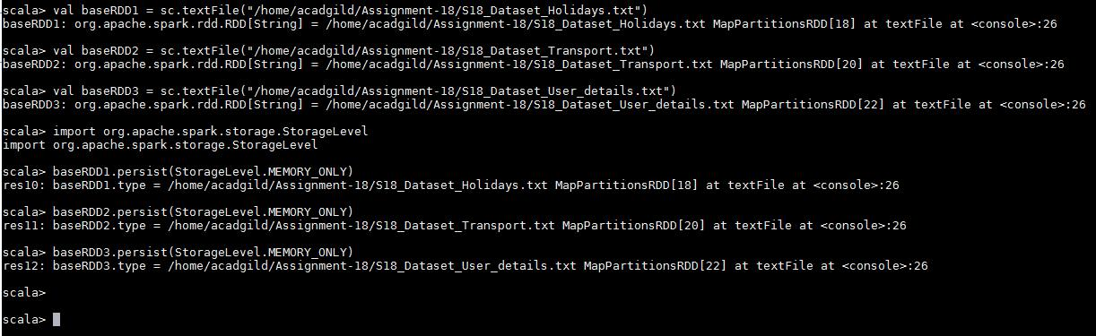
Problem Statement:-

- Which route is generating the most revenue per year

- What is the total amount spent by every user on air-travel per year

- Considering age groups of < 20 , 20-35, 35 > ,Which age group is travelling the most every year.

Solution:-

- Which route is generating the most revenue per year

Below is the code used:-
- val travel = baseRDD1.map(x =>

(x.split(",")(0).toInt,x.split(",")(1),x.split(",")(2),x.split(",")(3),x.split(",")(4)

.toInt,x.split(",")(5).toInt))
- val transport = baseRDD2.map(x => (x.split(",")(0),x.split(",")(1).toInt))

- val user = baseRDD3.map(x =>

(x.split(",")(0).toInt,x.split(",")(1),x.split(",")(2).toInt))

- val travelmap = travel.map(x=> x._4 -> (x._2,x._5,x._6))

- val transportmap = transport.map(x=> x._1 -> x._2)

- val join1 = travelmap.join(transportmap)

- val routeMap = join1.map(x => (x._2._1._1 -> x._2._1._3) -> (x._2._1._2 * x._2._2))

- val costsum = routeMap.groupByKey().map(x => x._2.sum -> x._1)

- val sortRevenue = costsum.sortByKey(false).first()
Output:-
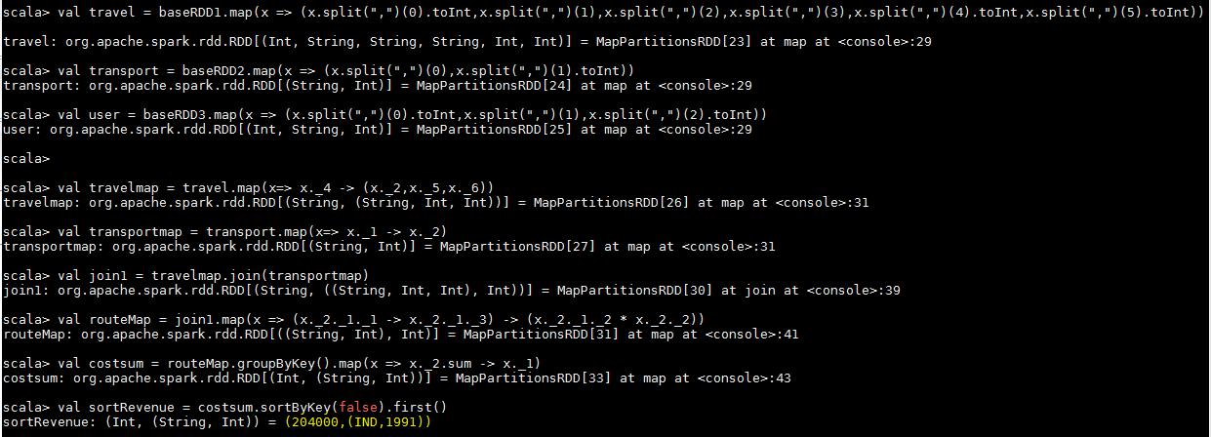

- What is the total amount spent by every user on air-travel per year

Below is the code used:-
- val userMap = travel.map(x => x._4 -> (x._1,x._5,x._6))

- val amtMap = userMap.join(transportmap)

- val spendMap = amtMap.map(x => (x._2._1._1, x._2._1._3) -> (x._2._1._2 * x._2._2))
- val total = spendMap.groupByKey().map(x => x._1 -> x._2.sum)

- total.foreach(println)

Output:-
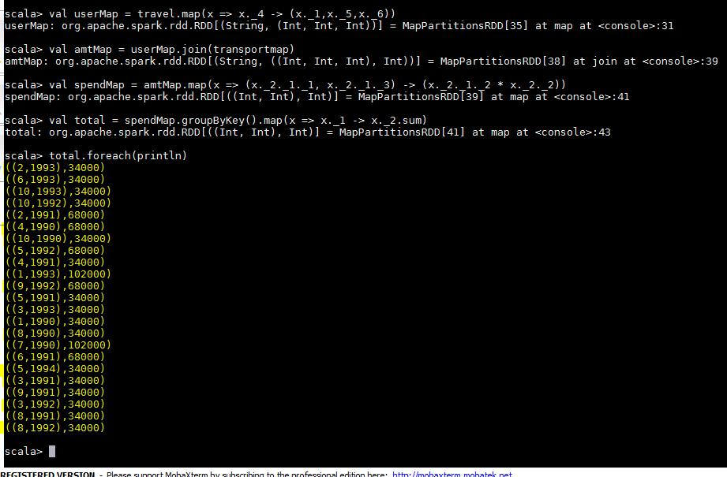

- Considering age groups of < 20 , 20-35, 35 > ,Which age group is travelling the most every year.

Below is the code used:-

- val AgeMap = user.map(x => x._1 -> {if(x._3<20) "20" else if(x._3>35) "35" else "20-35" })

- val UIDMap = travel.map(x => x._1 -> 1)

- val joinMap = AgeMap.join(UIDMap)

- val joinMap2 = joinMap.map(x => x._2._1 -> x._2._2)

- val groupKey = joinMap2.groupByKey.map(x => x._1 -> x._2.sum)

- val maxVal = groupKey.sortBy(x => -x._2).first()

Output:-
